**Games 101 – Critical Play Report – Mancala**

Composer: Gordon (Cunbo Li)

Email: [gordon.lee@nyu.edu](mailto:Gordon.lee@nyu.edu) or [cl3846@nyu.edu](mailto:cl3846@nyu.edu)

Mancala not only has a long history but is also popular in modern society. It looks like playing with simple rough materials, but it is not easy to master. In my point of view, we can improve Mancala strategy by moving your third pit to the beginning, emptying the right-most pit, and trying to capture opponent’s pieces.

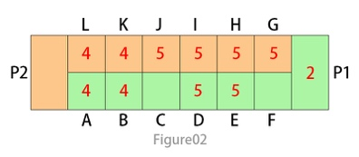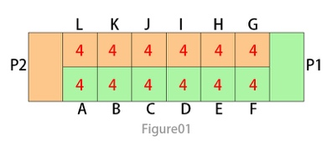The most important and useful tip is that you should start at the third pit on your side as the opening move. To be more specific, this tip is able to let you drop the last piece in your Mancala (the storage for your pieces and score area) and gives you another move. At the second move, I suggest moving the right-most hole. Because the last drop will be in opponent’s fourth pit, in order to prevent the third pit move as you did in your turn. The right most hole should always hold one piece so that it will give your chance to have a second move. For an instance of the opening move, P1 (Player1) starts first as Figure01. After his second move (including his second move), P1 established the formation seen in Figure02. On the P2 turn as Figure02, P2 should think of how to deal with Pit H and Pit G for a defensive move. Even though P2 can move Pit H to get a second move to deal Pit G, he is still in an inferior position because of accumulating of pieces on his side. P1 is able to move Pit B, D and E to fill the Pit F with one piece to enhance his strategy. Always trying to keep one piece at Pit F, in order to score your point, but also obtain the second move to build up your formation to set a strategy.

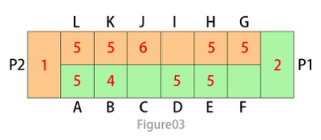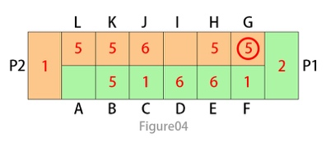Besides the tips for the opening move, another tactic to win Mancala is trying to capture your opponent’s stones. That is to say, always having the consciousness that emptying the opposite pit of your opponent and dropping your last pieces in this empty pit at your turn. Because this tactic not only scores large points but is also able to deconstruct the “Hoarding” strategy from your opponent. For example, at the situation of Figure03, P1 has empty pits at C and F. Move pieces at A will just drop the last stone off at Pit F (show as Figure04), so the marked pieces at Pit G are captured to P1’s Mancala. This is an ideal way to score a large number of points, so that trying to leave one piece at the left side of the empty pit will provide you with more chances to capture opponent’s stones.

As I mentioned above, “Hoarding” is another strategy that is used a lot in Mancala. But I do not really recommend this risky strategy, although it is very powerful at the end of the game. “Hoard” means the player stores a large number of stones in his pits, but not in his Mancala, to prevent his opponent from having enough stones to set his strategy. This is useful at the end of the game because all of the pieces in your pits and Mancala are scored. The reward is a high price. Pieces you’ve hoarded will have a high rate to be captured if you do not operate well by using “Hoarding” (The obvious paradox here is that “Capture” deconstructs formation of “Hoarding” and “Hoarding” prevents enough stones to take a “Capture”).

Based on what we’ve discussed above, it is easy to arrive at a conclusion that emptying the third hold of your side at the opening move, trying the best to capture the opponent’s pieces and operating well if using high-risk strategy are useful skills and consciousness when playing Mancala.